Assessment Schedule – 2016

Chemistry: Demonstrate understanding of the properties of organic compounds (91391)

Evidence Statement
Q | Evidence | Achievement | Achievement with Merit | Achievement with Excellence
ONE  (a) | 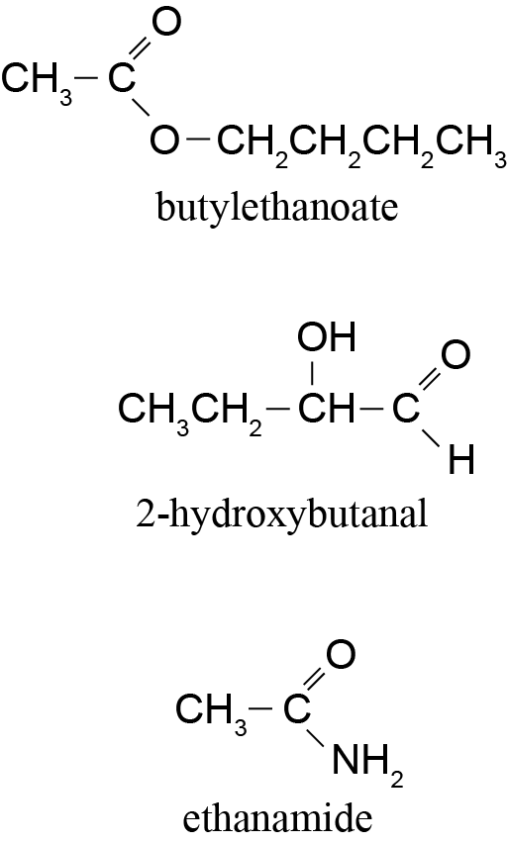 | - Two correct.
(b) | - Hydroxyl (alcohol).  - Amine / amino.  - Amide / peptide.  - Carboxylic acid. | - Three correct.
(c)(i)  (ii)  (iii)  (iv)  (v) | 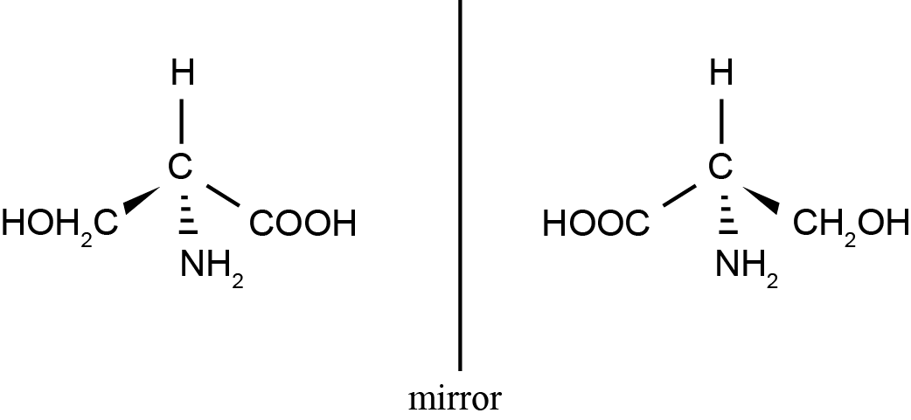  Glycine.  It does NOT have a chiral C, i.e. it needs four different groups around the central C atom, glycine only has three.  Dipeptides:  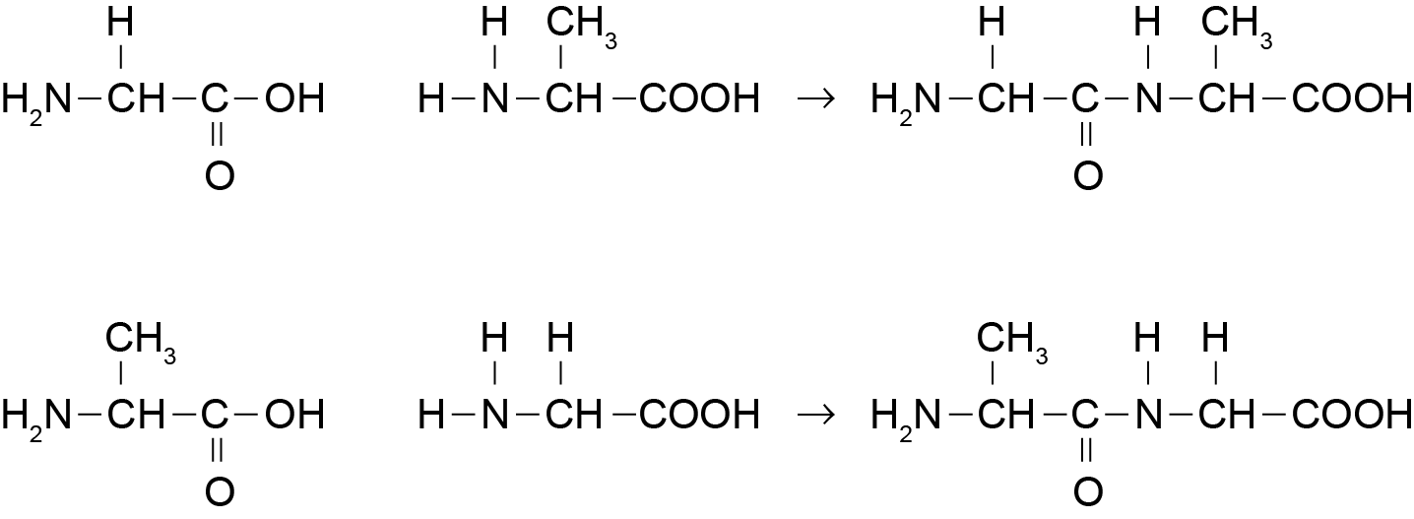  Condensation.  Two larger molecules are joined together with the elimination of a smaller molecule.  Acidic hydrolysis leaves COOH group intact and NH₂ group becomes protonated to form NH₃⁺.  H₃N⁺CH(CH₃)COOH H₃N⁺CH₂COOH | - Attempts to draw two 3-D structures but with careless error  OR  ONE correct 3-D structure.  - Glycine plus one relevant statement.  - Correct peptide linkage shown, but the structure is incorrect.  - Correct reaction type OR explanation.  - Recognises COOH forms, but incorrect structure  OR  Recognises NH₃⁺ formed. | - TWO correct 3-D images.  - Glycine plus explanation of chiral / asymmetric carbon.  - One correct dipeptide.  - Correct reaction type AND explanation.  - Correct structure for one amino acid AND a partial explanation OR  Correct hydrolysis products given. | - Both dipeptides are correctly shown.  - Correct hydrolysis products given, with explanation.

NØ | N1 | N2 | A3 | A4 | M5 | M6 | E7 | E8
No response;  no relevant evidence | 1a | 2a | 4a | 6a | 3m | 4m | 1e + 3m | 2e

Q | Evidence | Achievement | Achievement with Merit | Achievement with Excellence
TWO  (a)(i)  (ii) | Sodium borohydride / NaBH₄ (accept LiAlH₄)  Pentanal will produce a primary alcohol / pentan-1-ol.  CH₃CH₂CH₂CH₂CH₂OH  Pentan-2-one will produce a secondary alcohol / pentan-2-ol.  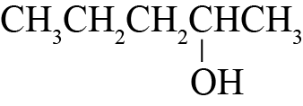 | - Correct name or formula of reagent.  - EITHER one correct classification  OR one correct structure. | - Correct name or formula of reagent.  AND  Both alcohols classified.  AND  Both structures are correct.
(b)(i)  (ii) | A: Propan-1-amine. (1-propanamine)  B: Propanal.  C: Propanoyl chloride.  D: Propan-2-one. (propanone)  A: Propan-1-amine (a primary amine)  CH₃CH₂CH₂NH₂ (propan-1-amine) will turn moist red litmus paper blue as it is basic.  CH₃CH₂CH₂NH₂ + H₂O → CH₃CH₂CH₂NH₃⁺ + OH–  Water: Dissolves in water.  Benedict’s solution will stay blue as primary amines do not react with Benedict’s reagent.  B: Propanal (An aldehyde)  Damp Litmus: No colour change.  Water: Dissolves in water.  Propanal will react with Benedict’s reagent, with the blue solution forming a (copper mirror) / brick red precipitate. Propanoic acid is formed.  CH₃CH₂CHO → CH₃CH₂COOH  C: Propanoyl chloride (An acyl chloride)  Damp Litmus: Turn blue litmus red  Water: Propanoyl chloride will react vigorously with water to produce propanoic acid and hydrogen chloride.  CH₃CH₂COCl + H₂O → CH₃CH₂COOH + HCl  Benedict’s solution will stay blue as the acyl chloride does not react with the Benedict’s, but instead reacts with the water present in the Benedict’s solution.  D: Propan-2-one (A ketone)  CH₃COCH₃ (propan-2-one)  Damp Litmus: No colour change.  Water: Dissolves in water.  Benedict’s solution: No reaction, so stays blue. | - THREE correct names.  - Correct reagent chosen for two substances with incomplete observations.  OR  ONE substance correctly identified with equation. | - TWO substances from A, B and C correctly identified with accurate observations.  - TWO correct equations.  OR  All FOUR substances are correctly identified, with accurate observations and ONE correct equation. | - All chemicals are correctly identified with accurate observations.  AND  TWO appropriate symbol equations given.

NØ | N1 | N2 | A3 | A4 | M5 | M6 | E7 | E8
No response; no relevant evidence | 1a | 2a | 3a | 4a | 2m | 3m | 1e  with minor error / omission | 1e

Q | Evidence | Achievement | Achievement with Merit | Achievement with Excellence
THREE  (a) | Structures:  S1: CH₃COOCH₂CH₂CH₃  S2: CH₃CH₂CH₂OH  S3: CH₃CH=CH₂  S4: CH₃CH₂CH₂Cl  S5: CH₃CH(Cl)CH₃  S6: CH₃COCl  S7: CH₃CONHCH₂CH₂CH₃  Reagent 1 = H₂O / H⁺ (dilute acid)  Reagent 2 = conc. H⁺ (H₂SO₄ or H₃PO₄)  Reagent 3 = NH₃ (alc) or conc. | - Any THREE correct structures.  - Any ONE fully correct reagent. | - At least SEVEN correct including ONE fully correct reagent. | - All structures and reagents correct.
(b) | Step 1: Butan-1-ol to but-1-ene.  Dehydration reaction (elimination reaction) using conc H₂SO₄.  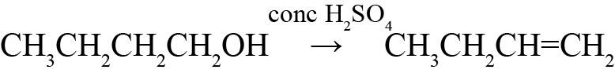  Step 2: But-1-ene to butan-2-ol.  Hydration reaction (addition reaction) using dil. H₂SO₄ (H⁺/H₂O)  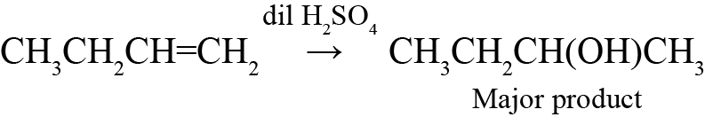  Step 3: Butan-2-ol (Major product) to butan-2-one.  Oxidation reaction of secondary alcohol to from a ketone using Cr₂O₇^{2–} / H⁺ under reflux.  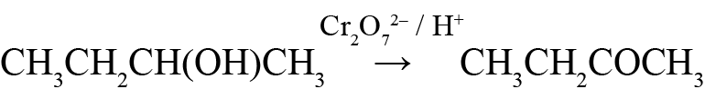  Other workable scheme are possible. | - ONE correct reagent.  - ONE correct conversion step. | - Workable scheme, with at least one fully correct reagent. | - All correct with full understanding.

(c)(i)  (ii) | One of these groups circled:  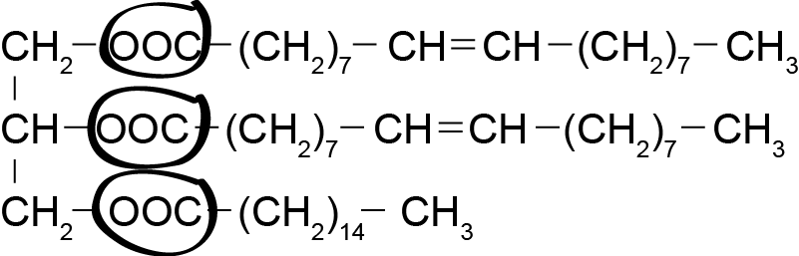  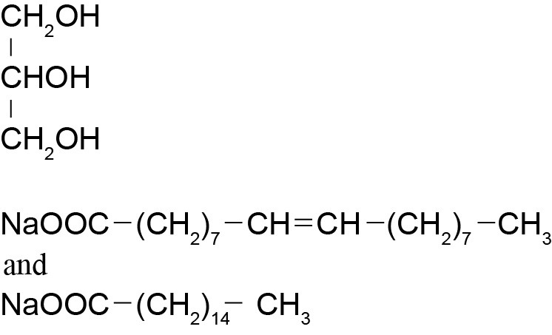 | - Ester functional group indicated.  - ONE correct product for hydrolysis reaction. | - All THREE products correct.

NØ | N1 | N2 | A3 | A4 | M5 | M6 | E7 | E8
No response; no relevant evidence | 1a | 2a | 4a | 5a | 2m | 3m  OR  2e BOTH with minor error / omission | 2e  ONE with a minor error / omission | 2e

Cut Scores
Not Achieved | Achievement | Achievement with Merit | Achievement with Excellence
0 – 7 | 8 – 13 | 14 – 19 | 20 – 24

